**SOFTWARE VERIFICATION, VALIDATION AND TESTING**

TESTING DOCUMENTATION

Automated Testing of Atlantbh Sarajevo

Prepared by:

**Džanin Mašić**

**Sara Nalo**

**Tijana Burazorović**

Proposed to:

**Samed Jukić, Assist. Prof. Dr.**

**Aldin Kovačević, Teaching Assistant**

Date of submission

22.01.2023

Contents

1. Introduction 3

1.1. About the Project 3

1.2. Project Functionalities and Screenshots 3

2. Test Plan 9

2.1. Scope 9

2.2. Testing Environment and Tools 9

3. Test Execution 9

3.1. Scenario: Visit the Home Page and Explore its Functionalities 9

3.2. Scenario: Visit the Blog Page 14

3.2. Scenario: Visit the Careers Page 18

3.3. Scenario: Visit the Services Page 20

3.4. Scenario: Test the Search Option 22

3.5. Scenario: Test the Remaining Features 24

4. Conclusion 26

4.1. Testing Summary 26

4.2. Final Thoughts 27

# 1. Introduction

## 1.1. About the Project

The aim of this project was to test the webpage of Atlantbh Sarajevo (link [here](https://www.atlantbh.com/)). This page is an informative page about the software development company Atlantbh and its extension in Bosnia and Herzegovina.

The most important information about services, general information, job offerings, scholarships and everything connected to the company can be found here.

## 1.2. Project Functionalities and Screenshots

When loading the webpage of Atlantbh, the following can be seen:

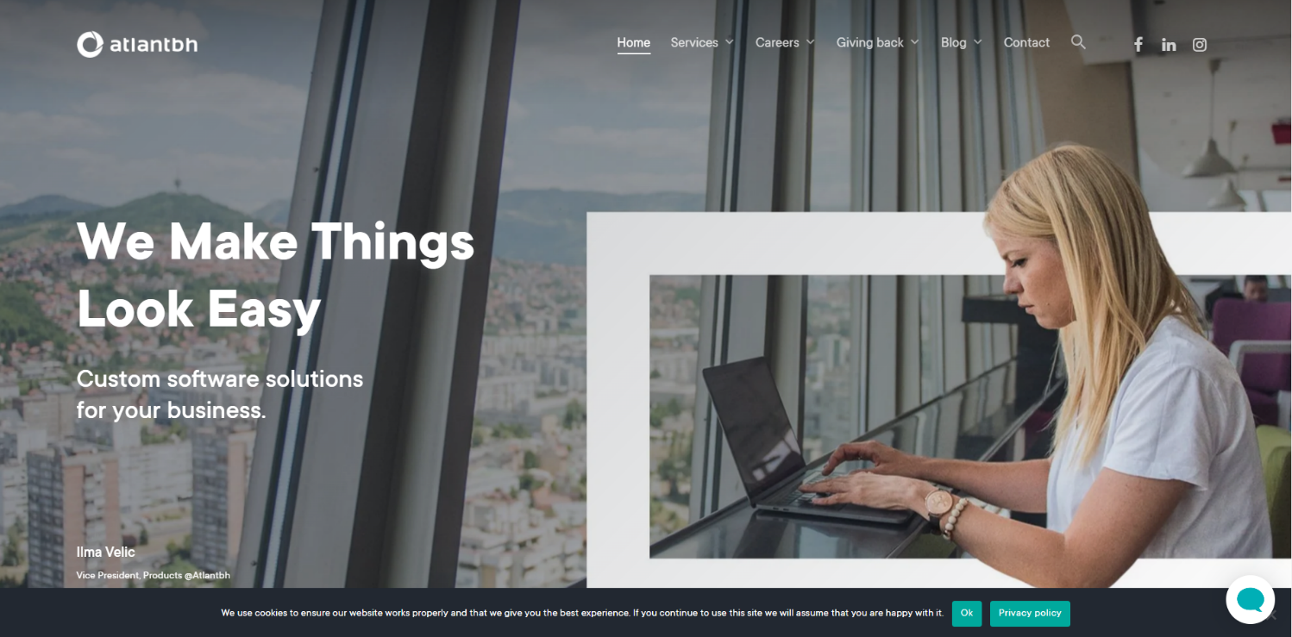

As seen in the screenshot, the page has a navbar in the upper right area, where home and contact button can be found, as well as dropdowns for services, careers, giving back, blog and buttons for social media (Facebook, Instagram and LinkedIn) which when clicked redirect the user to appropriate apps.

The dropdowns are displayed when the user hovers with their pointer over the navbar button which has a downwards pointing arrow. One of the dropdowns in the navbar can be seen here:

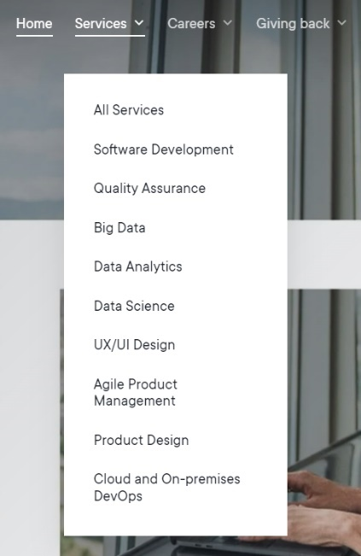

Furthermore, the user has the option to click on the navbar button which has a dropdown and will be redirected to the page for that button, as seen in the following screenshot:

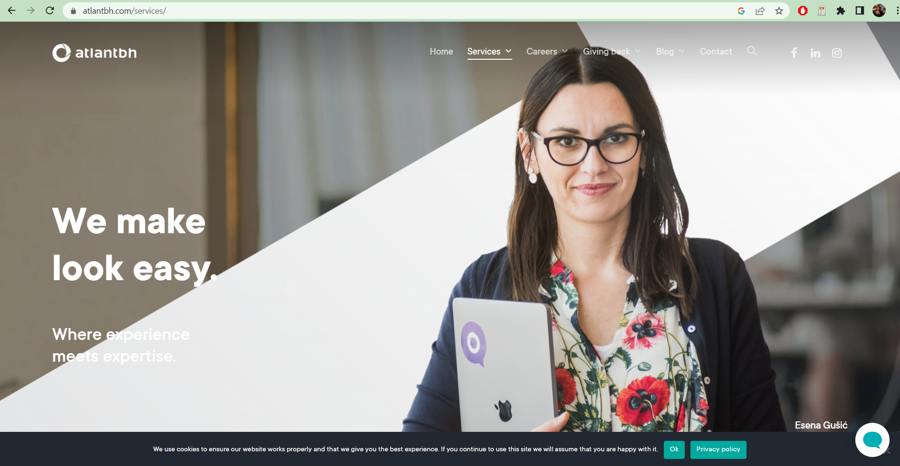

The user can also click on any of the options in the dropdown:

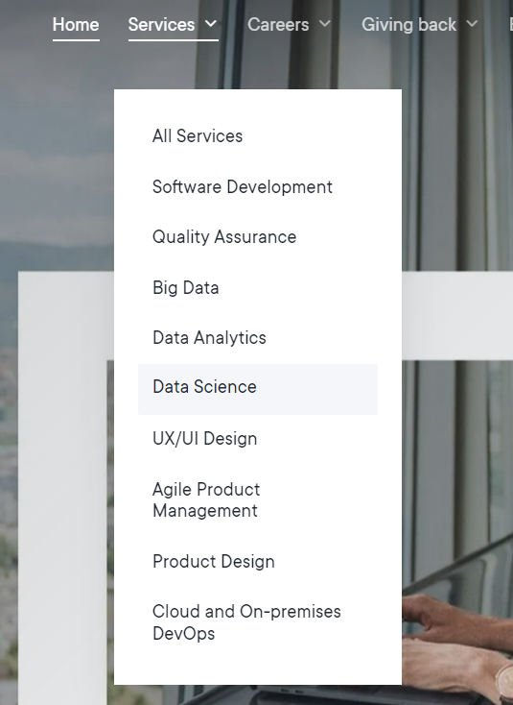

This will lead them to the appropriate page:

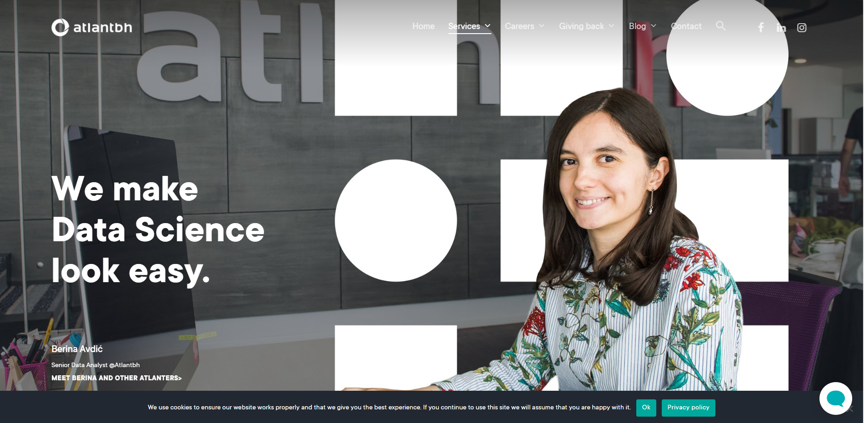

In the bottom right corner, there is a button for opening a chatbot within the webpage:

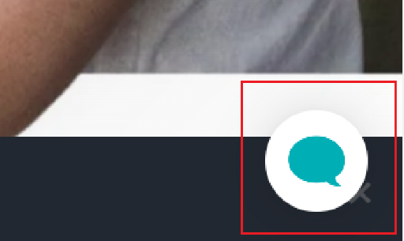

When opened, the bot has following options:

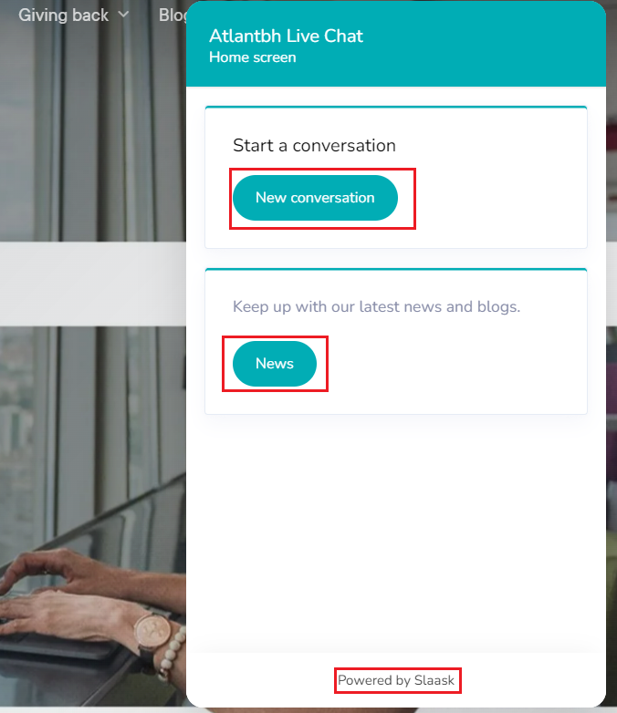

These can be clicked, and they lead to more options for the user.

As seen previously, the user can access the blog navbar and click on any of the options (for example, “Big Data”). This would lead them to the blog page of the Big Data where they can see the blog posts with the tag Big Data:

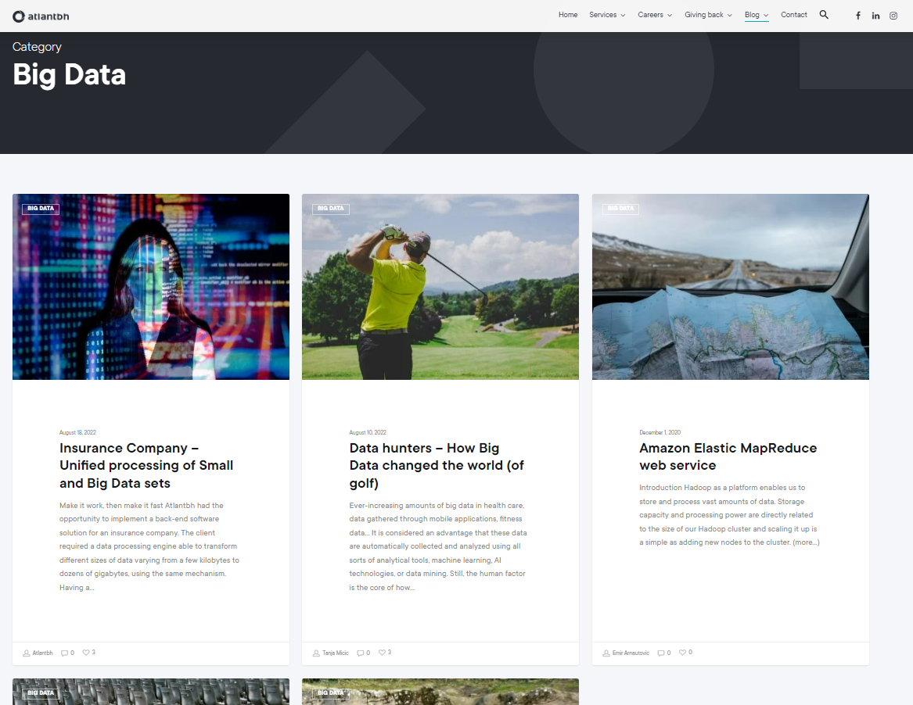

The user can then click on any of the blog posts, read the blog and leave the comment if they want to:

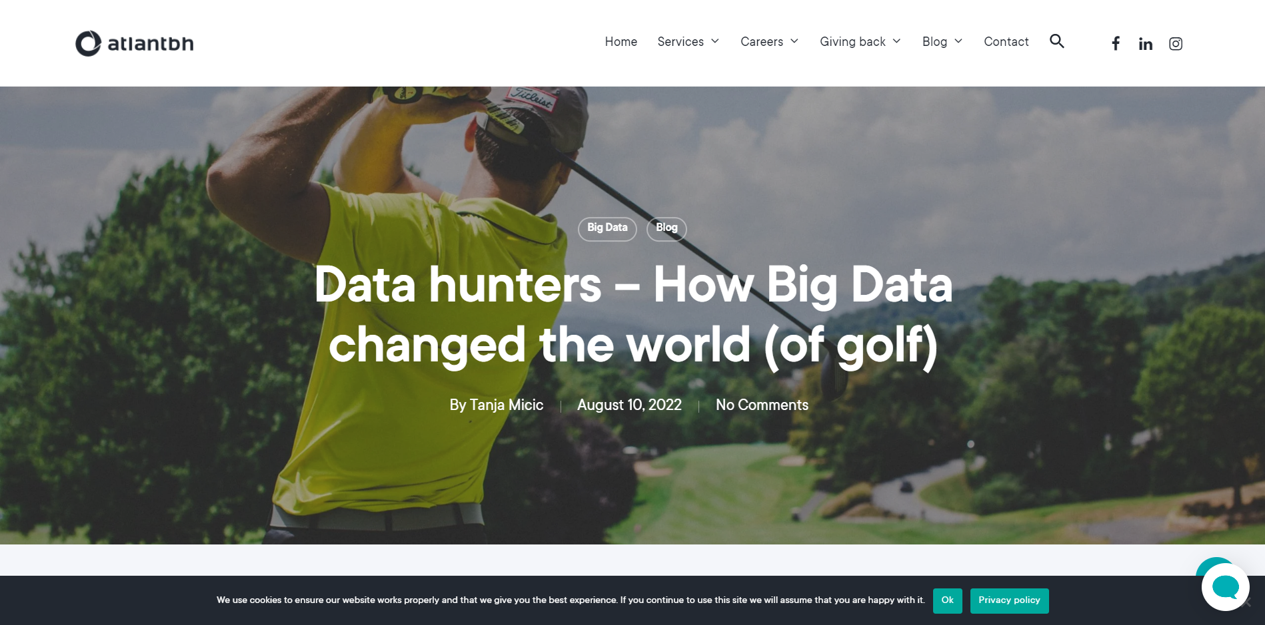

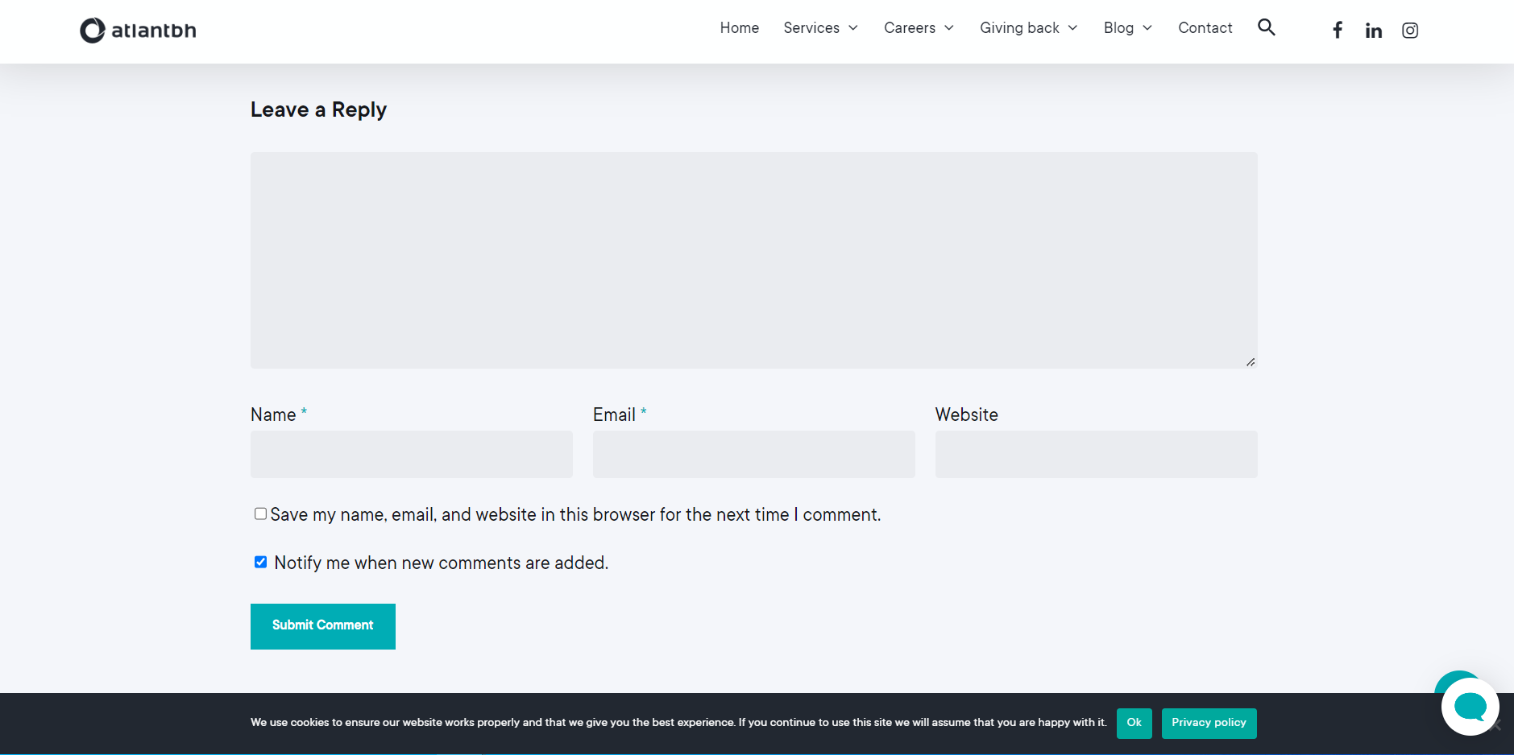

The user can also search for any keyword they wish to by clicking on the search button in the navbar:

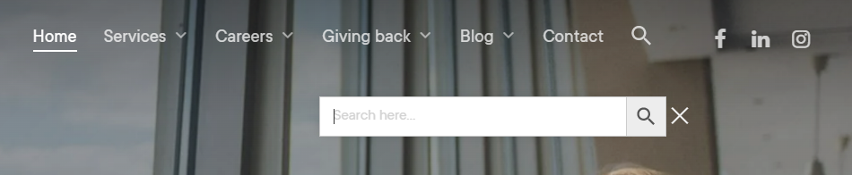

By typing any keyword and clicking on search, the appropriate result will be displayed (example: “development”):

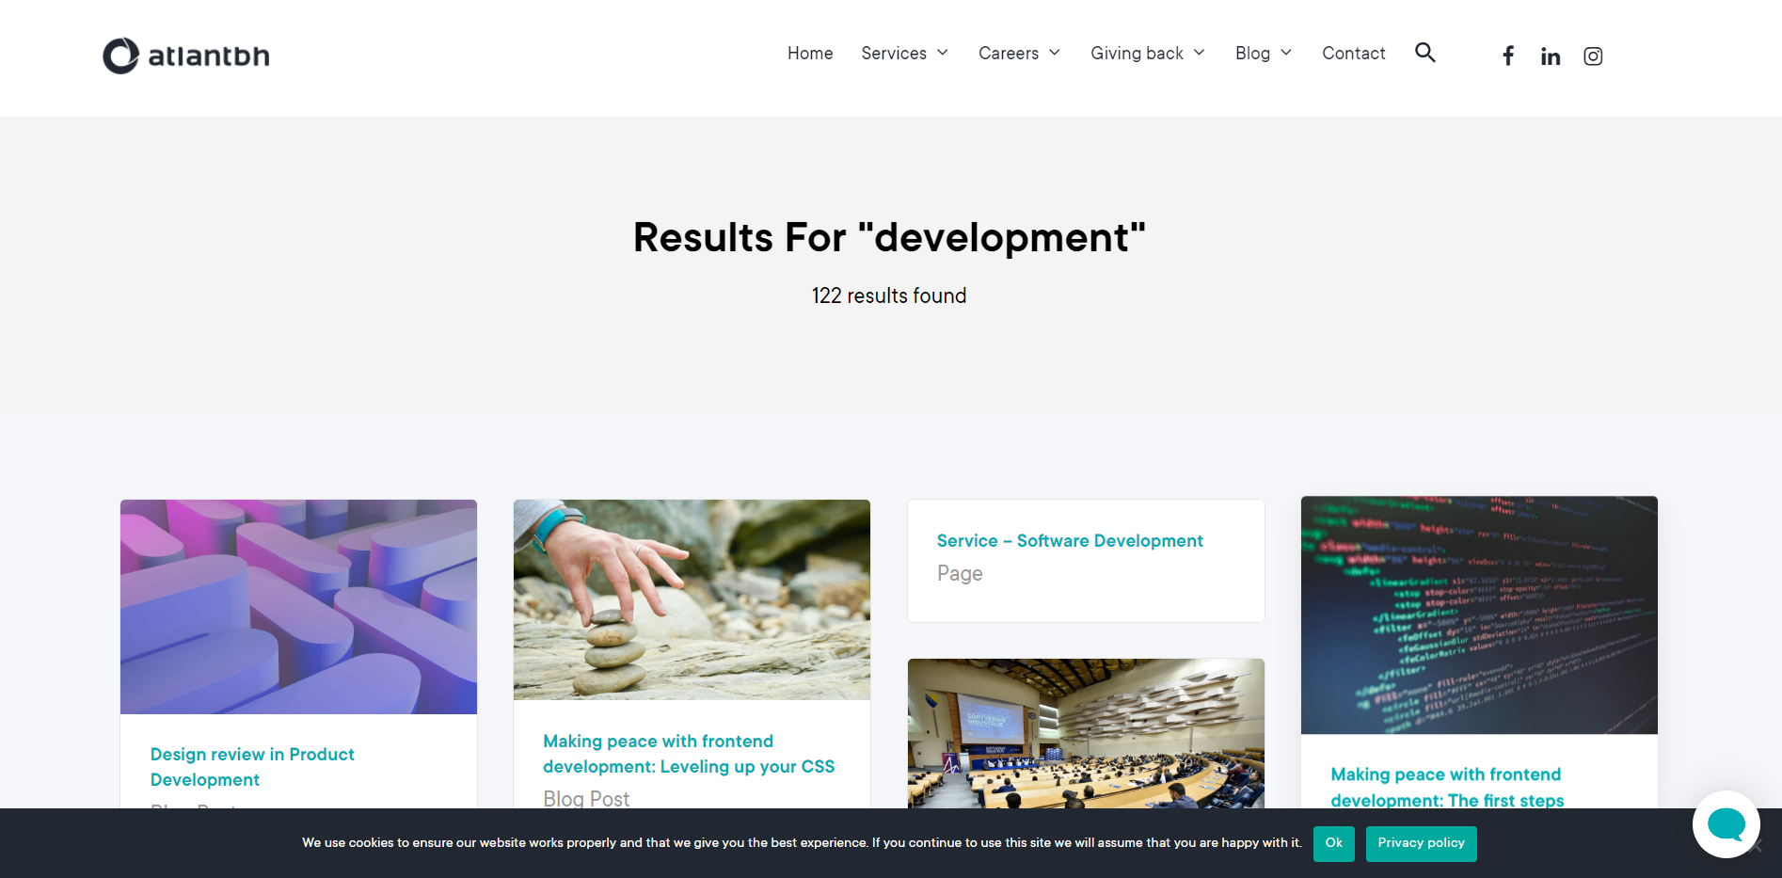

User can access anything found by search.

By clicking on the contact button in the navbar, the user will be redirected to contact page, where they can contact the company:

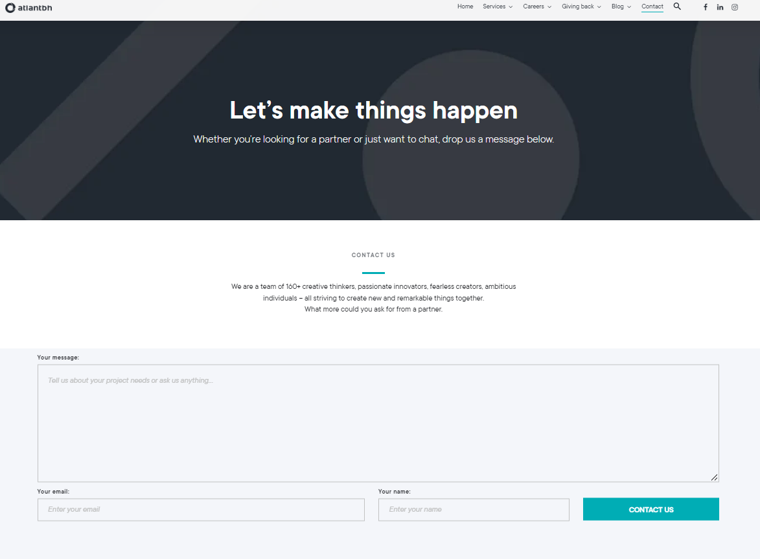

When scrolling down on the home page, the user can give their email to subscribe to the newsletter of the company:

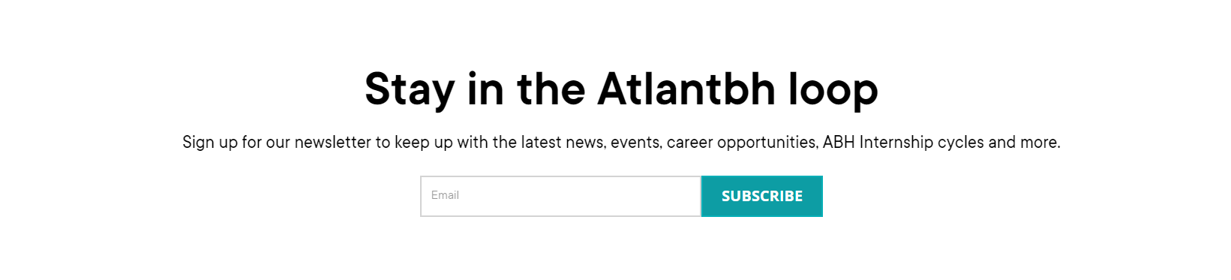

# 2. Test Plan

## 2.1. Scope

Since this is the informative page of the company, the aim of this project is to test all of the following functionalities of the page:

* Testing the homepage and subscribe to the newsletter feature
* Testing the search button and search feature as well as redirecting to a certain link in the search
* Testing the contact form
* Exploring the social media extensions
* Testing the navbar on the page and dropdown options, as well as the redirected pages they lead to
* Exploring the blog posts and testing the options to leave the comment and their checkboxes.
* Testing the chatbot frame and interacting with it

The following tests, produced to test the features, should cover most of the functionalities of the page. It was, however, decided not to test any of the comment, subscribe and contact options by submitting them, but only by filling them, as not to spam the page and the company with questions and inquiries done for the purpose of testing.

## 2.2. Testing Environment and Tools

The tests are written in Java programming language in Eclipse IDE and Selenium was used for testing the functionalities of the page, which will be apparent in the test code screenshots further on.

# 3. Test Execution

## 3.1. Scenario: Visit the Home Page and Explore its Functionalities

This scenario tests the functionalities of the home page of Atlantbh. Here, the functionality to subscribe to the newsletter will be tested, as well as social media buttons and chatbot offered by the app.

|  |  |  |  |  |
| --- | --- | --- | --- | --- |
| **Test Name:** Test Home Page | | | | |
| **Description:**  Check if the home page is responsive and if the user can describe to the newsletter | | | | |
| **Pre-condition(s):** | | | | |
| **Test Steps:**   1. Go to the home page 2. Assert that the homepage displays a certain text 3. Go to the Subscribe option in the homepage 4. Input email in the Email section 5. Assert that the text "Stay in the Atlantbh loop" is visible 6. Assert that the URL of the current page is as expected | **Test Data:**  In the 4th step of the test, the email [example@gmail.com](mailto:example@gmail.com) is typed in the email field. | **Expected Result:**  The user is taken to the home page of the app. They are able to input their email in the subscribe section. The text shown on the page is as expected. The URL of the page is as expected | **Actual Result:**  The user is taken to the homepage and is able to input their email in the subscribe section. All the assertions are true. | **Status:**  PASS |
| **Notes: The user does not sign up for the newsletter, as that would require the real user data** | | | | |

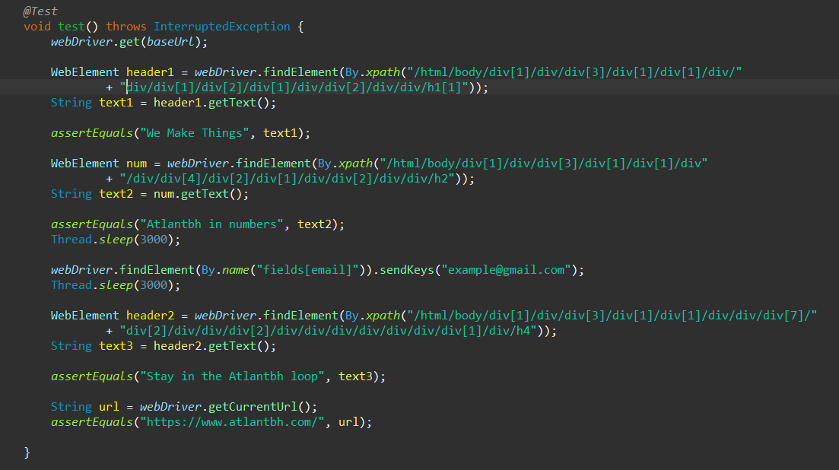

|  |  |  |  |  |
| --- | --- | --- | --- | --- |
| **Test Name:** Test Facebook Button | | | | |
| **Description:**  Check if the Facebook button is responsive and whether it redirects to the Facebook page of the company | | | | |
| **Pre-condition(s):** | | | | |
| **Test Steps:**   1. Go to the home page 2. Click on the Facebook button in the navbar 3. Go to the new tab 4. Assert that the text the tab leads to the Facebook page of Atlantbh | **Test Data:** | **Expected Result:**  The user is taken to the home page of the app. They are able to click on the Facebook button. The button redirects the to the Facebook page of the company. The URL of the page is as expected | **Actual Result:**  The user is taken to the homepage, is able to click on the Facebook button and is redirected to the Facebook page of the company. All the assertions are true. | **Status:**  PASS |
| **Notes:** | | | | |

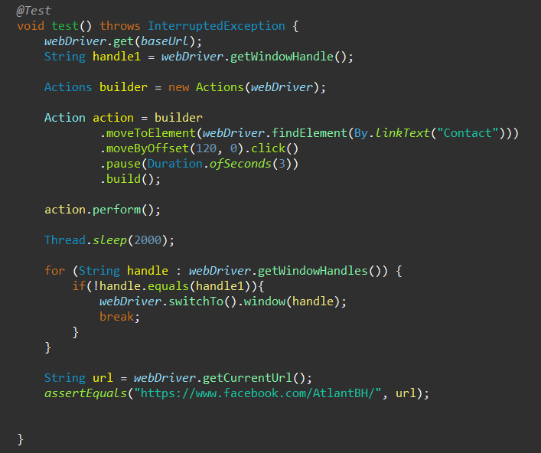

|  |  |  |  |  |
| --- | --- | --- | --- | --- |
| **Test Name:** Test LinkedIn Button | | | | |
| **Description:**  Check if the LinkedIn button is responsive and whether it redirect to the LinkedIn page | | | | |
| **Pre-condition(s):** | | | | |
| **Test Steps:**   1. Go to the home page 2. Click on the LinkedIn button in the navbar 3. Go to the new tab 4. Input user’s username in the username field 5. Input user’s password in the password field 6. Assert that the text the tab leads to the LinkedIn page | **Test Data:**  - In the 4th step, the email [example@gmail.com](mailto:example@gmail.com) is inserted in the username field.  - In the 5th step, the password “password” is inserted in the password field. | **Expected Result:**  The user is taken to the home page of the app. They are able to click on the LinkedIn button. The button redirects the to the LinkedIn page. They are able to input their username and password. The URL of the page is as expected | **Actual Result:**  The user is taken to the homepage, is able to click on the LinkedIn button and is redirected to the LinkedIn page. They succeed in inputting their username and password.  All the assertions are true. | **Status:**  PASS |
| **Notes: The user does not log in to LinkedIn, as that would require correct data.** | | | | |

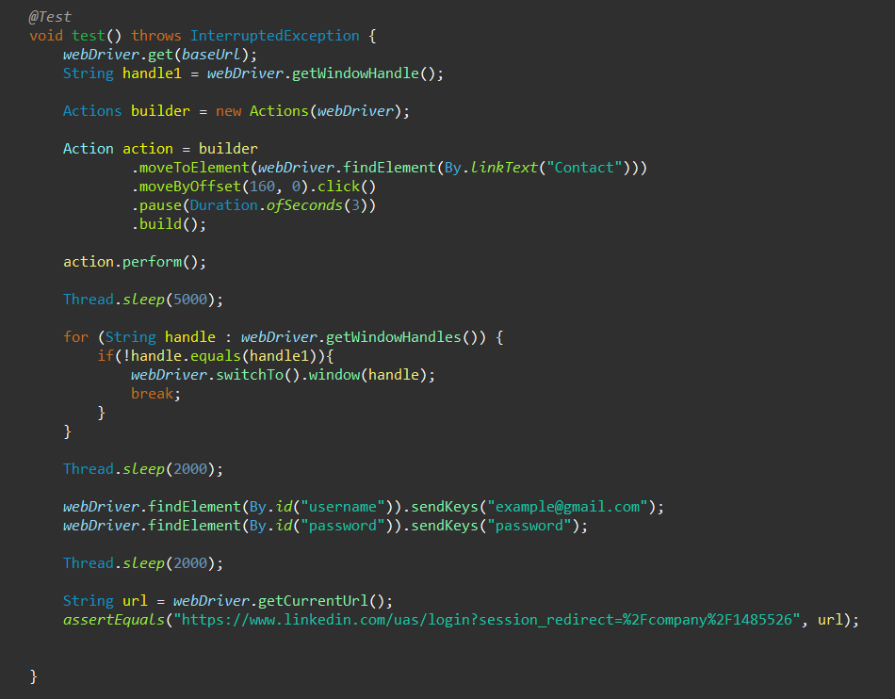

|  |  |  |  |  |
| --- | --- | --- | --- | --- |
| **Test Name:** Test Atlantbh chatbot | | | | |
| **Description:**  Check if the chatbot is responsive and if it is possible to get to the Slaask webpage through it | | | | |
| **Pre-condition(s):** | | | | |
| **Test Steps:**   1. Go to the home page 2. Accept the cookies for the page 3. Click on the chatbot icon 4. Go to the chatbot frame 5. Click on the “Powered by Slaask” option 6. Click on the “Learn more” button 7. Assert that the URL is as expected | **Test Data:** | **Expected Result:**  The user is taken to the home page of the app. They are able to click on the chatbot button. The chatbot is opened. The user is able to click on the “Powered by Slaask” option. The user is redirected within the chatbot frame and is able to click on the “Learn more” button.  The user is redirected to the Get Slaask page. | **Actual Result:**  The user is taken to the homepage, is able to click on the chatbot button which opens the chatbot, where user clicks on the “Powered by Slaask” option, which takes them to the appropriate page. | **Status:**  PASS |
| **Notes:** | | | | |

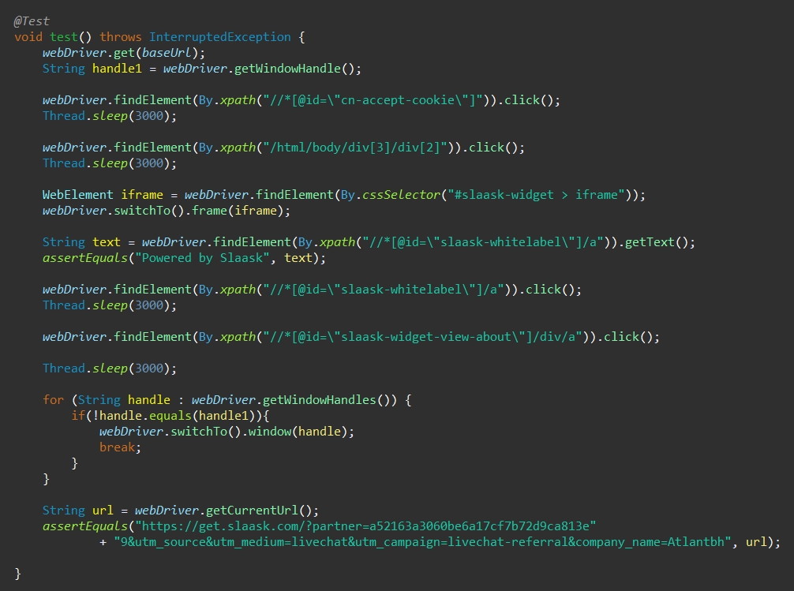

## 3.2. Scenario: Visit the Blog Page

Users want to be able to visit the blog page either by hovering over the blog button in the navbar and clicking the section they want to visit or clicking the blog button in the navbar and navigating to the wanted section. The user is also able to open the blog post and leave a comment.

|  |  |  |  |  |
| --- | --- | --- | --- | --- |
| **Test Name:** Test Blog Button | | | | |
| **Description:**  Check if blog button works, go to one section and open a blog post from it | | | | |
| **Pre-condition(s):** | | | | |
| **Test Steps:**   1. Go to the home page 2. Accept the cookies for the page 3. Click on the Blog button in the navbar 4. Click on the “Big Data” link 5. Click on the blog post 6. Assert that the blog post URL is as expected 7. Assert that the author is as expected 8. Click on the author 9. Assert that the current URL is as expected 10. Navigate back to the home page 11. Assert that the URL is as expected | **Test Data:** | **Expected Result:**  The user is taken to the home page of the app. They are able to click on the Blog button. The button redirects them to the Blog page. They are able to click on BIG DATA button. The user is redirected to big data page. They are able to find the blog post and click on it. The user is redirected to the blog post. They are able to click on the author, which leads them to the author profile. The user is able to navigate back to the homepage. All assertions are as expected. | **Actual Result:**  The user is taken to the homepage, is able to click on the Blog button and is redirected to the Blog page. They click on BIG DATA and are redirected there, where they click on the blog post and the author of the post.  The user is able to navigate back to the home page.  All the assertions are true. | **Status:**  PASS |
| **Notes:** | | | | |

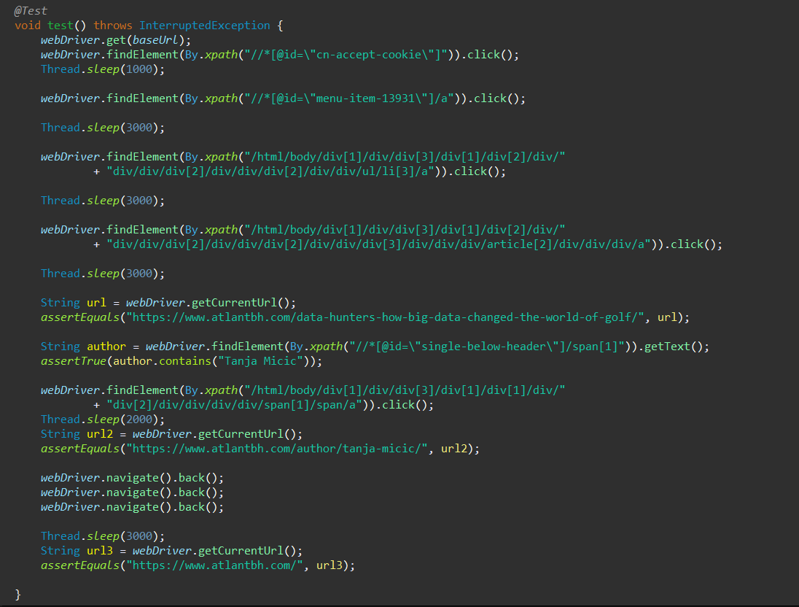

|  |  |  |  |  |
| --- | --- | --- | --- | --- |
| **Test Name:** Test Blog Hover | | | | |
| **Description:**  Check if blog hover works and go to one section | | | | |
| **Pre-condition(s):** | | | | |
| **Test Steps:**   1. Go to the home page 2. Hover over the Blog button in the navbar 3. Click on the “Tech Bites link 4. Assert that the blog URL is as expected 5. Navigate back to the home page 6. Assert that the URL is as expected | **Test Data:** | **Expected Result:**  The user is taken to the home page of the app. They are able to hover over the Blog button. The Blog dropdown is seen. They are able to click on Tech Bites button. The user is redirected to Tech Bites page. The user is able to navigate back to the homepage. All assertions are as expected. | **Actual Result:**  The user is taken to the homepage, is able to hover over the Blog button which displays the dropdown. They click on Tech Bites and are redirected there.  The user is able to navigate back to the home page.  All the assertions are true. | **Status:**  PASS |
| **Notes:** | | | | |

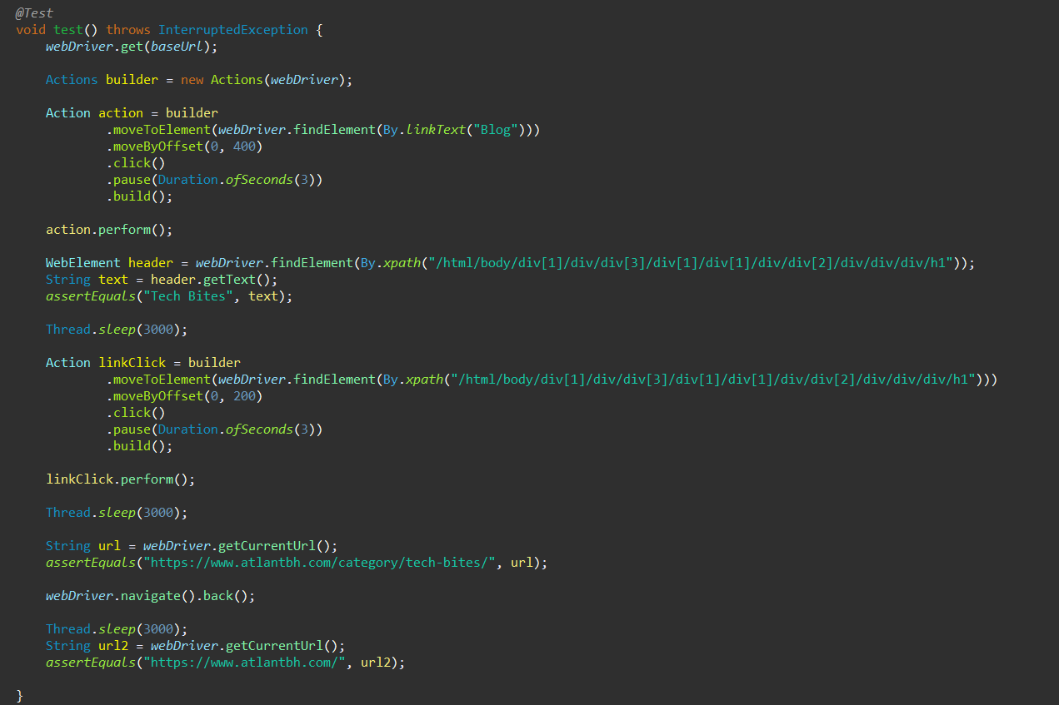

|  |  |  |  |  |
| --- | --- | --- | --- | --- |
| **Test Name:** Test Leave a Comment | | | | |
| **Description:**  Check if the user is able to leave a comment on a blog post | | | | |
| **Pre-condition(s):** | | | | |
| **Test Steps:**   1. Go to the home page 2. Accept the cookies for the page 3. Click on the Blog button in the navbar 4. Click on the blog post 5. Assert that the blog post URL is as expected 6. Go to the Leave a Reply section 7. Write a comment and all relevant data. 8. Check the first checkbox 9. Uncheck the second checkbox | **Test Data:**  - In the 7th step, the Reply “Nice article!” is inserted in the reply field. The author is inserted as “tester”, email as “example@gmail.com” and URL as “https://www.ibu.edu.ba/”. | **Expected Result:**  The user is taken to the home page of the app. They are able to click on the Blog button. The button redirects them to the Blog page. They are able to find the blog post and click on it. The user is redirected to the blog post. They are able to write a reply and their data, and click on all the checkboxes. | **Actual Result:**  The user is taken to the homepage, is able to click on the Blog button and is redirected to the Blog page. They click blog post input their data.  They click on both checkboxes. | **Status:**  PASS |
| **Notes: The reply is not submitted, as not to spam the web page.** | | | | |

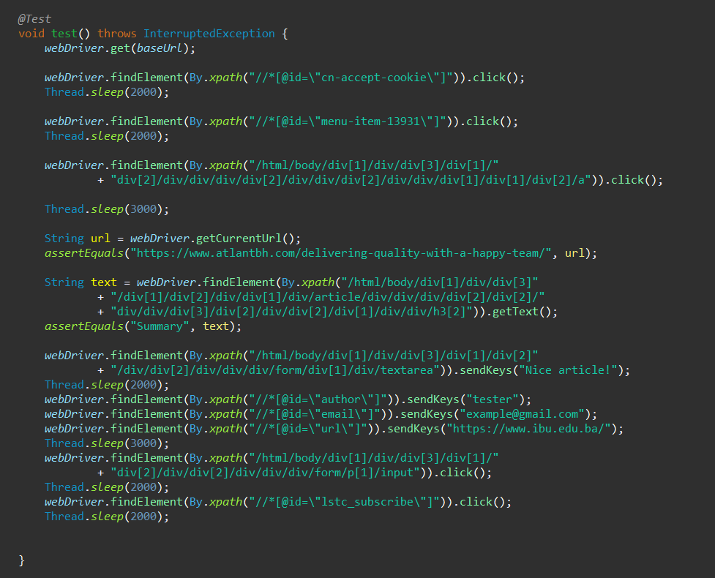

## 3.2. Scenario: Visit the Careers Page

Users want to be able to visit the Careers page by hovering over the Careers button in the navbar and clicking the section they want to visit or by clicking on the Careers button in the navbar and clicking the section they want to visit.

|  |  |  |  |  |
| --- | --- | --- | --- | --- |
| **Test Name:** Test Careers Button | | | | |
| **Description:**  Check if careers button works, go to one section and open it | | | | |
| **Pre-condition(s):** | | | | |
| **Test Steps:**   1. Go to the home page 2. Click on the Careers button in the navbar 3. Click on the “Culture” link 4. Assert that text is as expected 5. Assert that URL is as expected | **Test Data:** | **Expected Result:**  The user is taken to the home page of the app. They are able to click on the Careers button. The dropdown is displayed. They are able to click on Culture button. The user is redirected to Culture page. The text and URL of the page are as expected. | **Actual Result:**  The user is taken to the homepage, is able to click on the Careers button the dropdown is shown. They click on Culture and are redirected there. All the assertions are true. | **Status:**  PASS |
| **Notes:** | | | | |

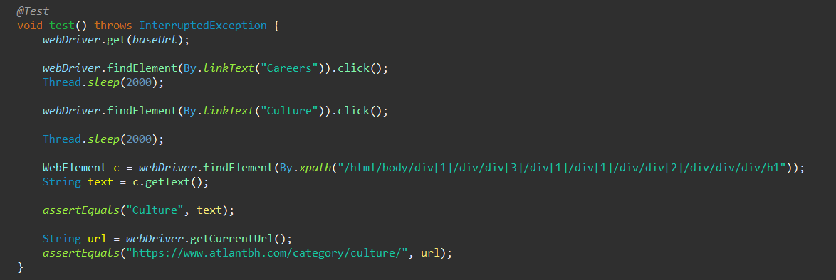

|  |  |  |  |  |
| --- | --- | --- | --- | --- |
| **Test Name:** Test Careers Hover | | | | |
| **Description:**  Check if careers hover works, go to one section and open it | | | | |
| **Pre-condition(s):** | | | | |
| **Test Steps:**   1. Go to the home page 2. Hover over the Careers button in the navbar 3. Click on the “Atlantbh QAmp” link 4. Assert that text is as expected 5. Assert that URL is as expected 6. Navigate back to the home page 7. Assert that URL is as expected | **Test Data:** | **Expected Result:**  The user is taken to the home page of the app. They are able to hover over the Careers button. The dropdown is displayed. They are able to click on Atlantbh QAmp button. The user is redirected to QAmp page. The user is able to navigate back to the homepage. All assertions are as expected. | **Actual Result:**  The user is taken to the homepage, is able to hover over the Careers button the dropdown is shown. They click on QAmp and are redirected there. They are able to navigate back. All the assertions are true. | **Status:**  PASS |
| **Notes:** | | | | |

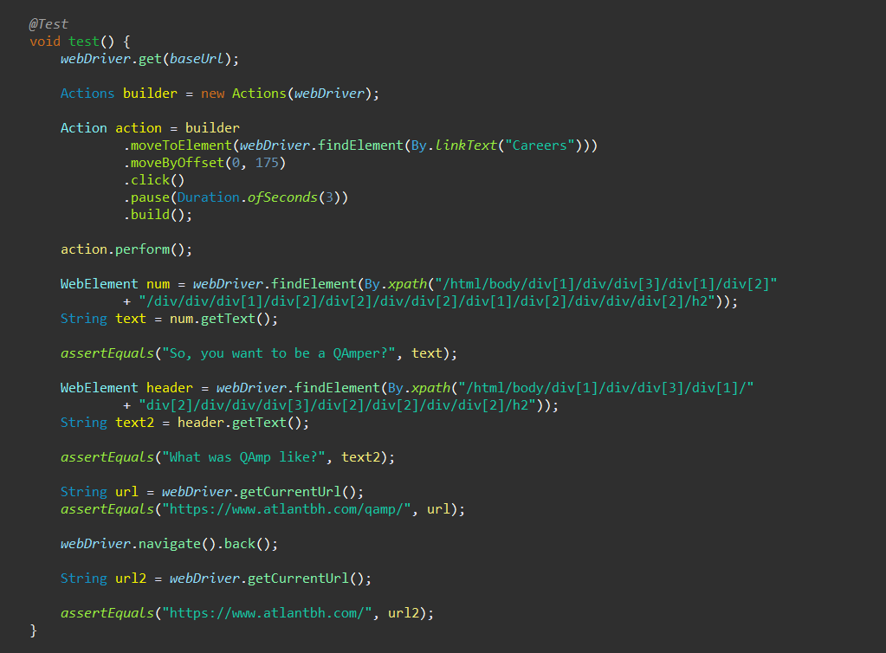

## 3.3. Scenario: Visit the Services Page

Users want to be able to visit the Services page by hovering over the Services button in the navbar and clicking the section they want to visit or by clicking on the Services button in the navbar and clicking the section they want to visit.

|  |  |  |  |  |
| --- | --- | --- | --- | --- |
| **Test Name:** Test Services Button | | | | |
| **Description:**  Check if Services button works, go to one section and open it | | | | |
| **Pre-condition(s):** | | | | |
| **Test Steps:**   1. Go to the home page 2. Click on the Services button in the navbar 3. Click on the “Data Science” link 4. Assert that text is as expected 5. Assert that URL is as expected 6. Navigate back to the home page 7. Assert that URL is as expected | **Test Data:** | **Expected Result:**  The user is taken to the home page of the app. They are able to click on the Services button. Dropdown is displayed. They are able to click on Data Science button. The user is redirected to Data Science page. The text and URL of the page are as expected. The user is able to navigate back to homepage. All assertions are as expected. | **Actual Result:**  The user is taken to the homepage, is able to click on the Services button the dropdown is shown. They click on Data Science and are redirected there. They are able to navigate back. All the assertions are true | **Status:**  PASS |
| **Notes:** | | | | |

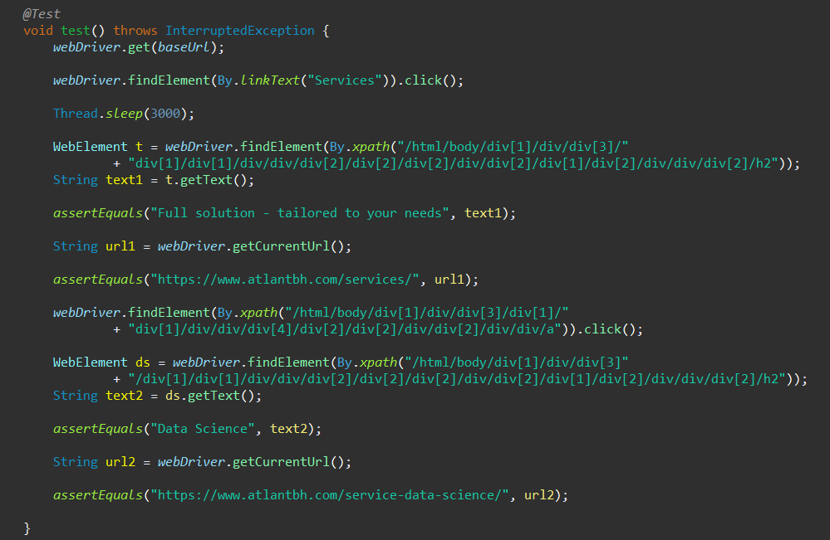

|  |  |  |  |  |
| --- | --- | --- | --- | --- |
| **Test Name:** Test Services Hover | | | | |
| **Description:**  Check if Services hover works, go to one section and open it | | | | |
| **Pre-condition(s):** | | | | |
| **Test Steps:**   1. Go to the home page 2. Hover over the Services button in the navbar 3. Click on the “Software Development” link 4. Assert that text is as expected 5. Assert that URL is as expected 6. Navigate back to the home page 7. Assert that URL is as expected | **Test Data:** | **Expected Result:**  The user is taken to the home page of the app. They are able to hover over the Services button. The dropdown is displayed. They are able to click on Software Development button. The user is redirected to Software Development page. The user is able to navigate back to the homepage. All assertions are as expected. | **Actual Result:**  The user is taken to the homepage, is able to hover over the Services button, where the dropdown is shown. They click on Software Development and are redirected there. They are able to navigate back. All the assertions are true. | **Status:**  PASS |
| **Notes:** | | | | |

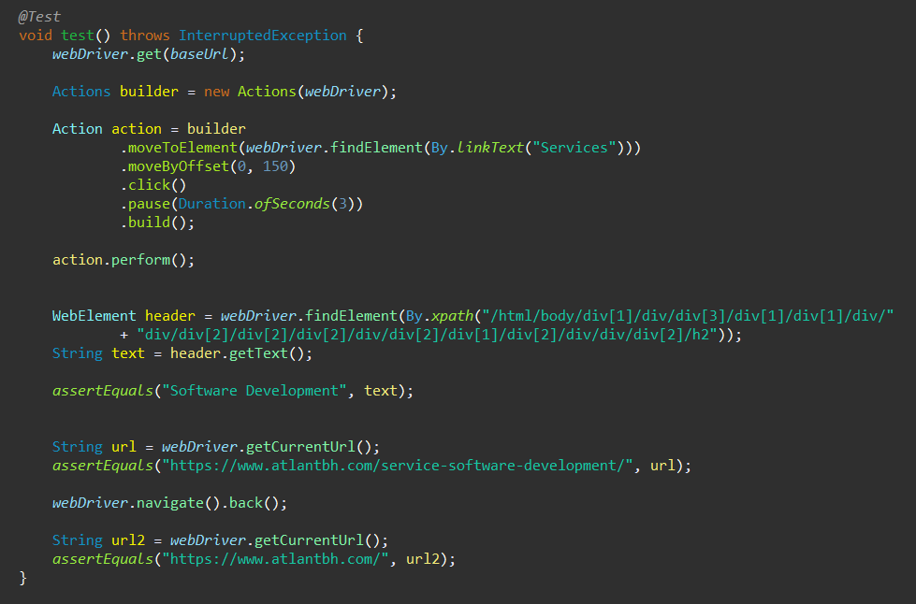

## 3.4. Scenario: Test the Search Option

The user is able to access the search option and search for the term they want to. The results are displayed and they are able to click on one of them.

|  |  |  |  |  |
| --- | --- | --- | --- | --- |
| **Test Name:** Test Search Button general | | | | |
| **Description:**  Check if Search button works, go to general response and open it | | | | |
| **Pre-condition(s):** | | | | |
| **Test Steps:**   1. Go to the home page 2. Accept the cookies for the page 3. Click on the Search button in the navbar 4. Type in “ux/ui design“ 5. Click on search 6. Click on general response 7. Assert that text is as expected 8. Assert that URL is as expected 9. Navigate back to the home page 10. Assert that URL is as expected | **Test Data:**  - In the 4th step, the “ux/ui design“ is typed in the Search field. | **Expected Result:**  The user is taken to the home page of the app. They are able to click on the Search button. The input field is displayed. They are able to type in their inquiry. The user is redirected to search results page. They are able to click on general result which redirects them to Services page. The user is able to navigate back to the homepage. All assertions are as expected. | **Actual Result:**  The user is taken to the homepage, is able to click on the Search button, the input field is shown. They type in inquiry and click on search. They are redirected to responses. They click on general response which leads them to Services page. They are able to navigate back. All the assertions are true. | **Status:**  PASS |
| **Notes:** | | | | |

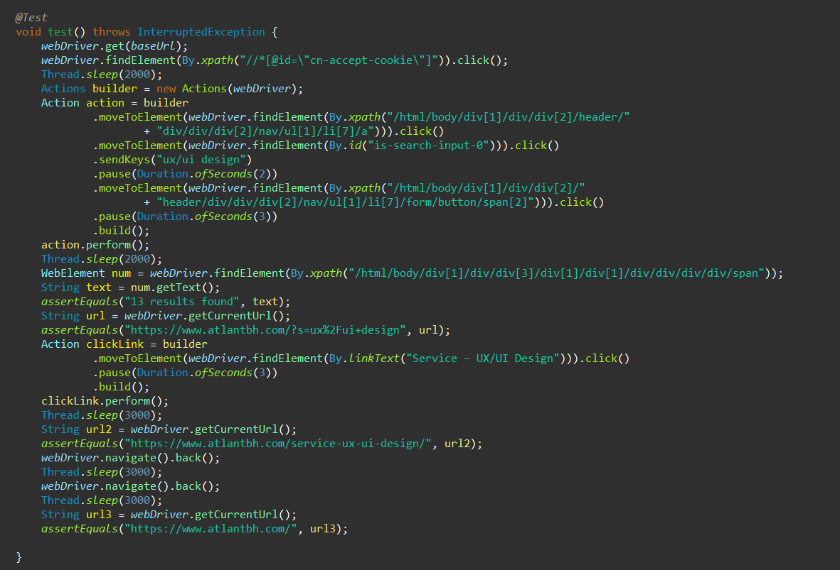

|  |  |  |  |  |
| --- | --- | --- | --- | --- |
| **Test Name:** Test Search Button specific | | | | |
| **Description:**  Check if Search button works, go to specific response and open it | | | | |
| **Pre-condition(s):** | | | | |
| **Test Steps:**   1. Go to the home page 2. Accept the cookies for the page 3. Click on the Search button in the navbar 4. Type in “development“ 5. Click on search 6. Click on specific response 7. Assert that text is as expected 8. Assert that URL is as expected 9. Navigate back to the home page 10. Assert that URL is as expected | **Test Data:**  - In the 4th step, the “development“ is typed in the Search field. | **Expected Result:**  The user is taken to the home page of the app. They are able to click on the Search button. The input field is displayed. They are able to type in their inquiry. The user is redirected to search results page. They are able to click on specific result which redirects them to a blog post. The user is able to navigate back to the homepage. All assertions are as expected. | **Actual Result:**  The user is taken to the homepage, is able to click on the Search button, the input field is shown. They type in inquiry and click on search. They are redirected to responses. They click on specific response which leads them to the blog post. They are able to navigate back. All the assertions are true. | **Status:**  PASS |
| **Notes:** | | | | |

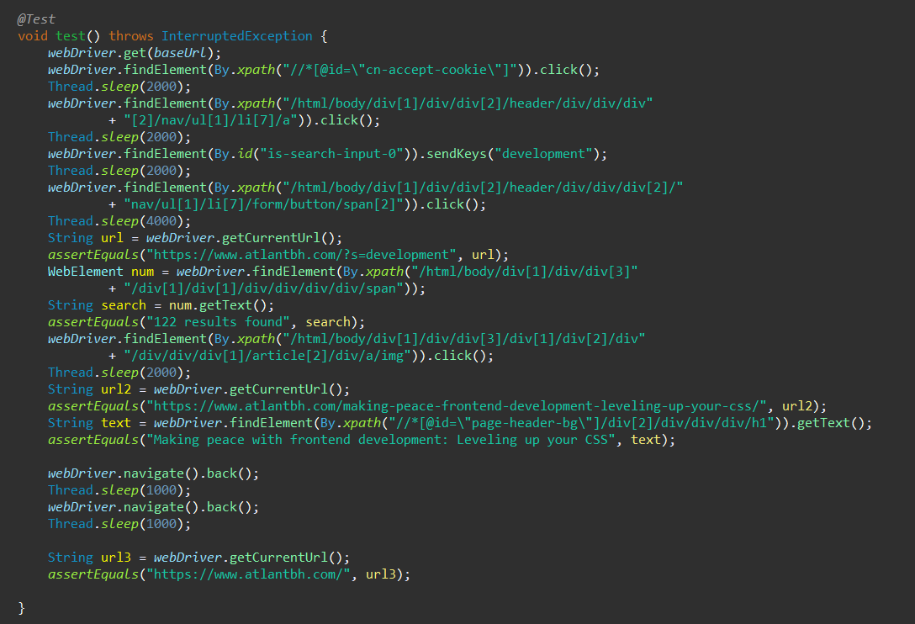

## 3.5. Scenario: Test the Remaining Features

The user is able to click on the Contact option and fill out the contact form to contact the company.

The user is able to hover over the Giving Back option and click the Scholarships button.

|  |  |  |  |  |
| --- | --- | --- | --- | --- |
| **Test Name:** Test Contact | | | | |
| **Description:**  Check if Contact button works, fill in the form | | | | |
| **Pre-condition(s):** | | | | |
| **Test Steps:**   1. Go to the home page 2. Click on the Contact button in the navbar 3. Assert that text is as expected 4. Type in “This is my message“ in the ask us field 5. Type in [example@gmail.com](mailto:example@gmail.com) in email field 6. Type in “Sara” in name field 7. Assert that URL is as expected 8. Navigate back to the home page 9. Assert that URL is as expected | **Test Data:**  - In the 4th step, “This is my massage“ is typed in the message field.  - In the 5th step, “[example@gmail.com](mailto:example@gmail.com)” is typed in email field  - In the 6th step, “Sara” is typed in name field | **Expected Result:**  The user is taken to the home page of the app. They are able to click on the Contact button. The user is able to input their data. The user is able to navigate back to the homepage. All assertions are as expected. | **Actual Result:**  The user is taken to the homepage, is able to click on the Contact button, they are redirected to the Contact page. They type in inquiry. They are able to navigate back. All the assertions are true. | **Status:**  PASS |
| **Notes: The Contact form is not submitted as not to spam the website.** | | | | |

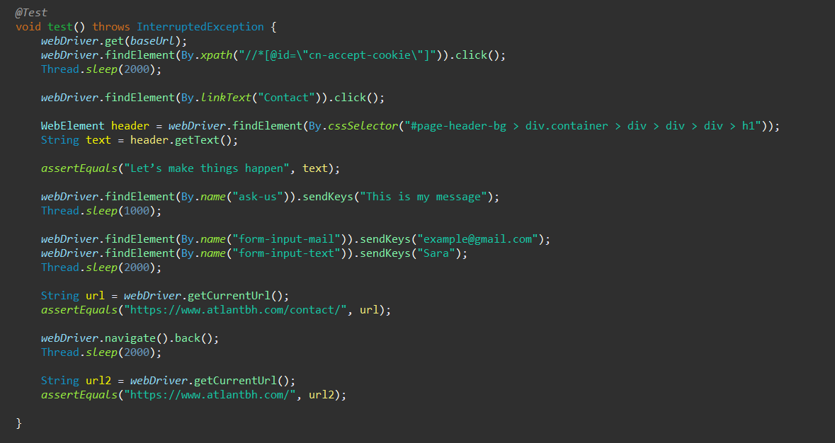

|  |  |  |  |  |
| --- | --- | --- | --- | --- |
| **Test Name:** Test Giving Back Hover | | | | |
| **Description:**  Check if Giving Back hover works, go to one Scholarships and open it | | | | |
| **Pre-condition(s):** | | | | |
| **Test Steps:**   1. Go to the home page 2. Hover over the Giving Back button in the navbar 3. Click on the “Scholarships” link 4. Assert that text is as expected 5. Assert that URL is as expected 6. Navigate back to the home page 7. Assert that URL is as expected | **Test Data:** | **Expected Result:**  The user is taken to the home page of the app. They are able to hover over the  Giving Back button. The dropdown is displayed. They are able to click on Scholarships button. The user is redirected to Scholarships page. The user is able to navigate back to the homepage. All assertions are as expected. | **Actual Result:**  The user is taken to the homepage, is able to hover over the Giving Back button, where the dropdown is shown. They click on Scholarships and are redirected there. They are able to navigate back. All the assertions are true. | **Status:**  PASS |
| **Notes:** | | | | |

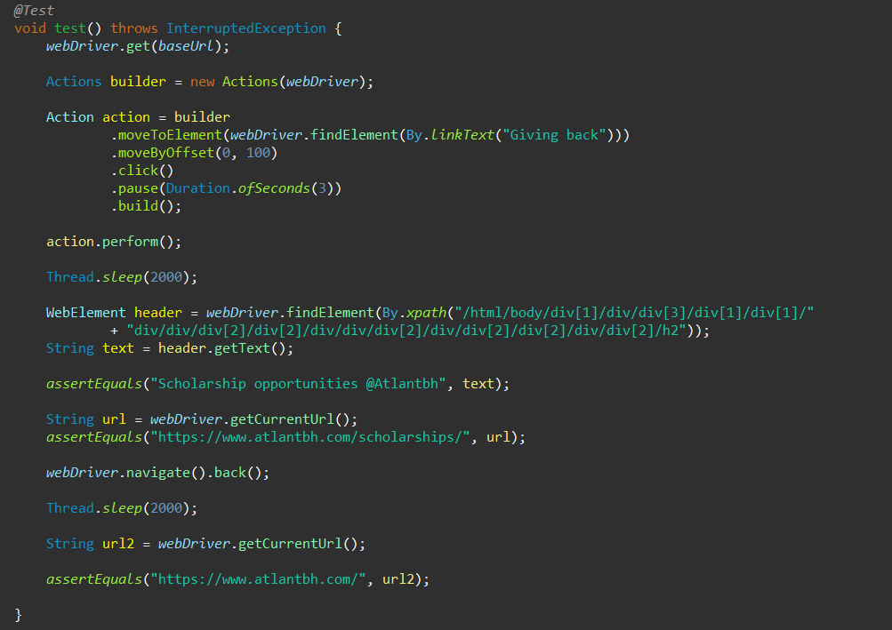

# 4. Conclusion

## 4.1. Testing Summary

The summary of all executed tests:

|  |  |  |  |
| --- | --- | --- | --- |
| **Testing Tool** | **Total Tests** | **Passed Tests** | **Failed Tests** |
| Tests are written with Selenium in Java programming language using Eclipse IDE. | 15 | 15 | 0 |

## 4.2. Final Thoughts

After conducting a number of tests on the webpage of Atlantbh, it is evident that the webpage is working as intended. The page is highly functional and responsive.

Through the tests, no obvious errors were met, but some inconsistencies were evident. It was noticed that in the navbar, some of the buttons which have dropdown menu, when clicked, redirect to appropriate page, while others when clicked just display the dropdown. However, this is not viewed as an error, but rather as a feature that’s not completely developed. It would be recommended for the developers to make the navbar more consistent in this sense.